BONNET SHORES FIRE DISTRICT
Combined Budget Workshop and Special Council Meeting
Agenda²
Thursday, May 21, 2026 @ 8:00am

Date/Time | Thursday, May 21, 2026 – 8:00am
Place: | Bonnet Shores Fire District Community Center - 130 Bonnet Shores Road, Narragansett, RI
Zoom¹: | Virtual access is being provided only as a convenience and is not an official “location” where access to the meeting is guaranteed. If any technical, host, or operator issues arise with Zoom, the meeting will still proceed. Therefore, being physically present at the meeting is the only way to guarantee complete and uninterrupted access to the meeting.  Zoom Link: https://us02web.zoom.us/j/88405178925
Designated area for recording/ photography | To preserve order and decorum, and to avoid interfering with the ability of spectators to see and hear, any members of the public video recording or photographing the meeting should do so from the designated area.

Call To Order
- Pledge of Allegiance
- Moment of Silence

Budget Workshop

Public Input on FY 2026–2027 Budget - Members of the public may comment on budget-related matters only. Please approach the microphone or raise your hand on Zoom, identify yourself including BSFD address. Comments limited to three (3) minutes per person.

Budget Topics to be Discussed:
- Overview of current FY 2026–2027 budget status
- Review of the Proposed FY 2026–2027 Operating Budget as prepared by the Treasurer
- Discussion and possible amendments
- Review of the Proposed FY 2026–2027 Capital Budget as prepared by the Treasurer
- Discussion and possible amendments

The Budget Workshop will conclude and the Special Council Meeting will immediately follow.

Special Council Meeting - Public comment limited to the Budget Workshop portion of the meeting.

- Motion, Discussion, consideration, revision and possible vote to adopt the FY 2026–2027 Operating and Capital Budgets, as amended.

Motion to Adjourn

Attachments:

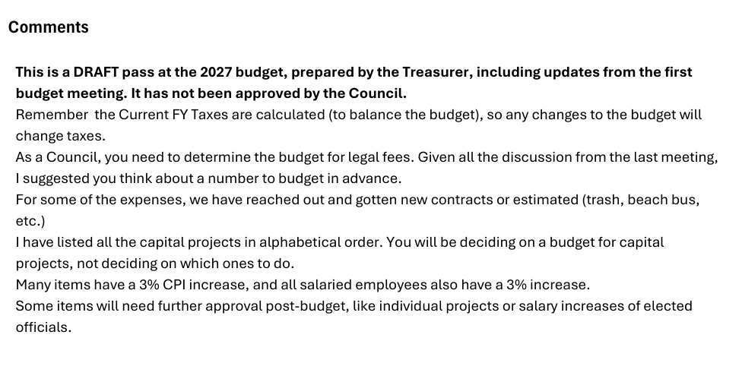
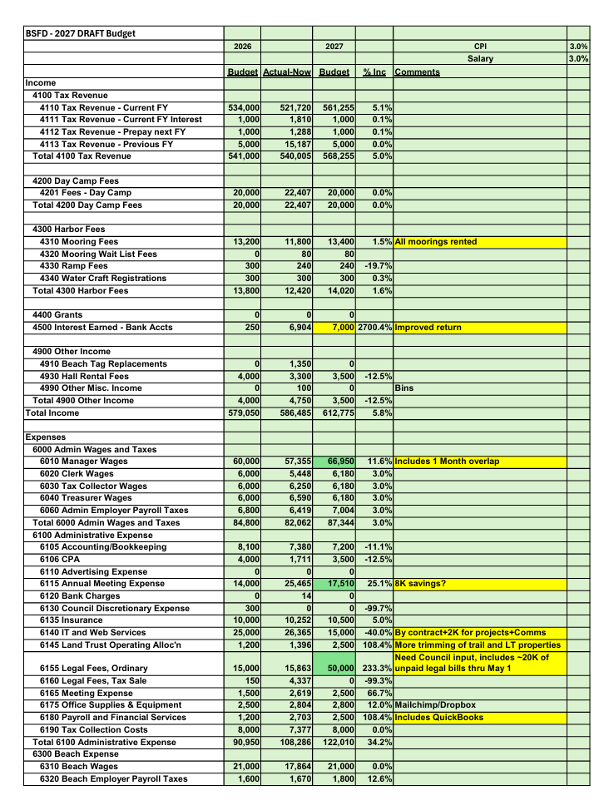
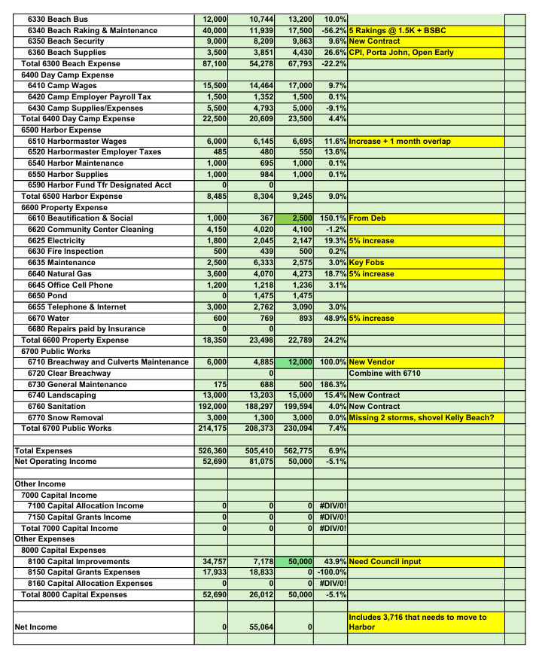
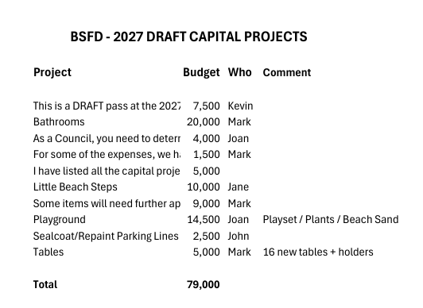

¹ Zoom Details
BSFD is inviting you to a scheduled Zoom meeting.
Topic: BSFD Budget Workshop & Special Council Meeting
Time: May 21, 2026 08:30 AM Eastern Time (US and Canada)
Join Zoom Meeting
https://us02web.zoom.us/j/88405178925
View meeting insights with Zoom AI Companion
https://us02web.zoom.us/launch/edl?muid=ba5a5a90-ce49-446c-87fa-773ced653a9b
Meeting ID: 884 0517 8925
---
One tap mobile
+13052241968,,88405178925# US
+13017158592,,88405178925# US (Washington DC)
---
Join by SIP
• 88405178925@zoomcrc.com
Join instructions
https://us02web.zoom.us/meetings/88405178925/invitations?signature=PUfvB4zl5ft3HSLOppeKFtOC3c2X-AfA36imQ0aT2Wo

² R.I. Gen. Laws § 42-46-6(b): Nothing contained herein shall prevent a public body, other than a school committee, from adding items to the agenda for discussion purposes only, if the added item was not known or could not have been reasonably known 48 hours in advance of the meeting; provided, however, that the public body may not vote on the added item.
² ADA Accommodations: The BSFD is committed to providing reasonable accommodations for individuals with disabilities. Anyone requiring an accommodation is encouraged to contact the District Manager at least 48 hours before the meeting to allow adequate preparation. Requests received after that time will be addressed to the extent reasonably practicable.
² Disclaimer: Written materials that may be referenced or distributed by individual Council members in connection with agenda items are the submissions of those individual members and are not official communications or findings of the Bonnet Shores Fire District Council unless formally adopted by vote of the Council. The publicly posted agenda is intended to satisfy the notice requirements of Rhode Island General Laws § 42-46-6.

